

***INSTITUTE OF INFORMATION TECHNOLOGY***

***JAHANGIRNAGAR UNIVERSITY***

**Number of Assignment :** 01

**Submission Date :** 14/06/2023

**Course Tittle :** Human Computer Interaction

**Course Code :** ICT - 4109

**Submitted To Submitted By**

Mehrin Anannya Md. Shakil Hossain

Lecturer Roll – 2023

IIT – JU 4th year 1st Semester

IIT – JU

**Question:** Suggest some improvement of your Mobile Device with respect to Hardware that relating to HCI.

**Solution:**

My Device is Xiaomi Redmi Note 5 Pro

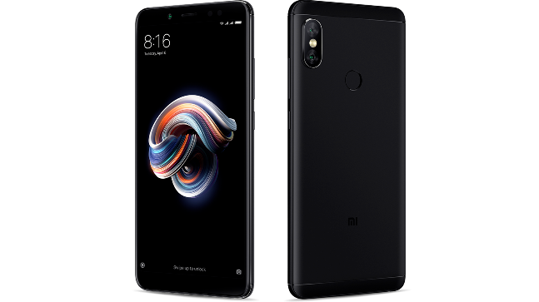

**Xiaomi Redmi Note 5 Pro problems**

1. OEM Unlock option missing

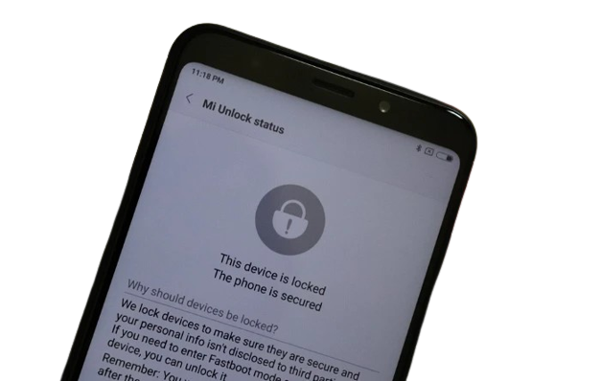

1. The left speaker isn’t working

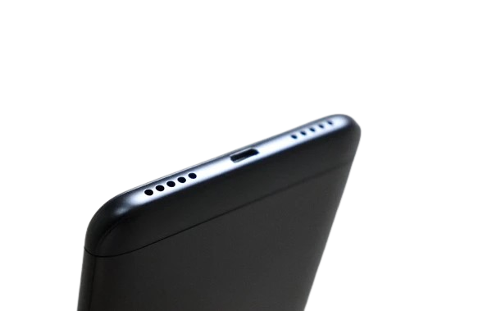

1. Portrait camera problems

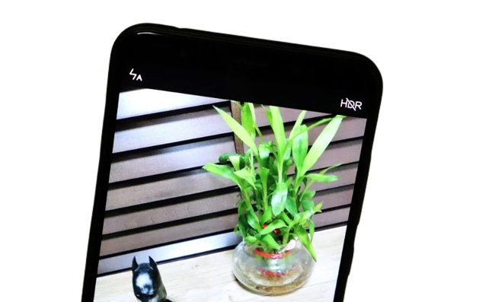

1. Microphone issues

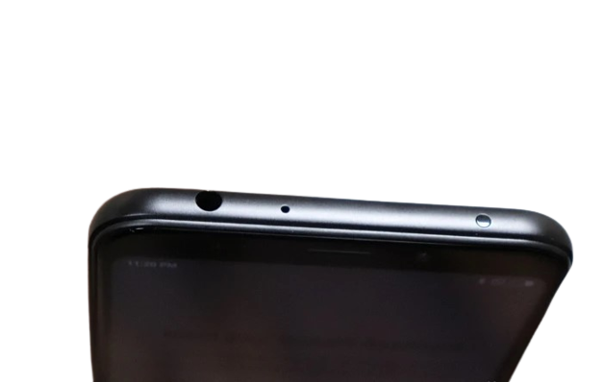

1. Sensors stopped working after latest update

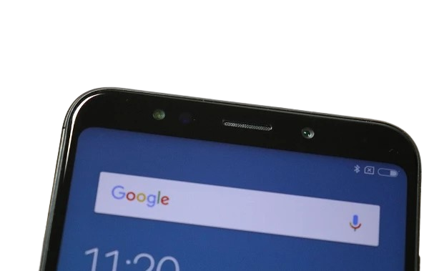

1. Low sound output when using the audio jack
2. Network connectivity issues
3. Phone Running Too Slow
4. Battery Drain Problem
5. Slow Charging

Here are some hardware-related improvements for mobile devices that could enhance the Human-Computer Interaction experience:

1. **Ergonomic design:** Mobile devices could be designed with ergonomics in mind, to make them more comfortable and easier to hold for extended periods of time. This could include changes to the shape, weight distribution, or texture of the device.
2. **Flexible displays:** Flexible displays could enable new form factors and use cases for mobile devices, allowing users to fold or roll up their screens for storage or transport.
3. **Larger screens:** A larger screen would make it easier for users to view content and interact with their device, without having to constantly zoom in and out or scroll. This could be particularly useful for tasks such as browsing the web, reading emails, or watching videos.
4. **Eye-tracking technology:** Eye-tracking technology could be integrated into mobile devices to allow for more natural interactions and improved accessibility.
5. **Improved camera technology:** Cameras are an important component of many mobile devices, and improving their resolution, image stabilization, and low-light performance could enhance the user's experience when capturing photos and videos.
6. **Advanced biometric authentication:** Biometric authentication methods, such as facial recognition or iris scanning, could be improved to provide faster and more accurate identification of users.
7. **Modular design:** A modular design could allow users to easily upgrade or replace individual components of their device, such as the battery or camera, rather than having to replace the entire device.
8. **Haptic feedback:** Haptic feedback features could enhance the user's experience by providing tactile feedback when they touch the screen or press a button. This could help users feel more connected to their device, and enable them to better understand how their actions are being interpreted by the device.
9. **Better batteries:** Improved battery technology could allow for longer battery life, reducing the need for frequent charging and improving the user's overall experience.
10. **More durable materials:** Stronger and more durable materials could help protect mobile devices from damage when dropped or bumped. This could reduce the need for costly repairs or replacements, and enable users to use their devices with greater peace of mind.
11. **Faster processors:** Mobile devices should have faster processors that can handle demanding tasks such as gaming and video editing. This will improve the overall performance of the device and make it more responsive to user input.
12. **More storage:** Mobile devices should have more storage space to accommodate large files such as high-resolution photos and videos. This will also allow users to install more apps and games.